Amazon Food Reviews Analysis Report

Introduction
This report presents an analysis of customer reviews for food products sold on Amazon.
The objective is to understand customer sentiment and identify key areas of praise and concern to support better business decision-making.

Dataset Overview
The dataset consists of Amazon Fine Food Reviews, containing customer ratings, review text, and product information.
It includes over 500,000 reviews, providing a diverse and rich source of customer feedback.

Data Cleaning and EDA
Missing values and duplicate records were removed to improve data quality.
Text data was standardised through lowercasing and removal of punctuation.
Exploratory analysis revealed that most reviews are positive, with common words relating to taste and quality.
Visualisations such as word clouds, review length distributions and count of review stars were used to understand patterns.
Word Clouds:
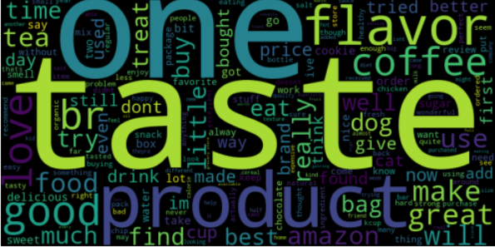
Review Length Distribution:
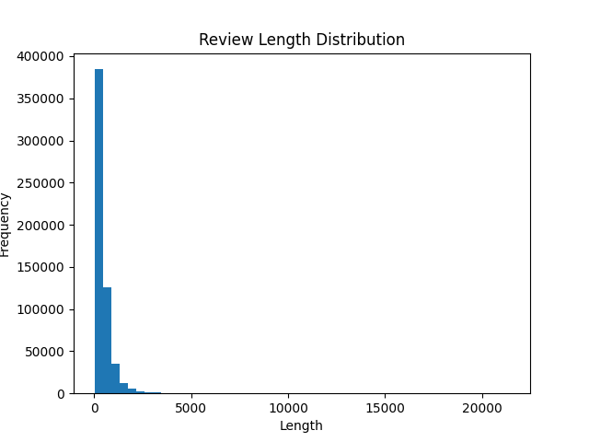
Count of Review Stars:
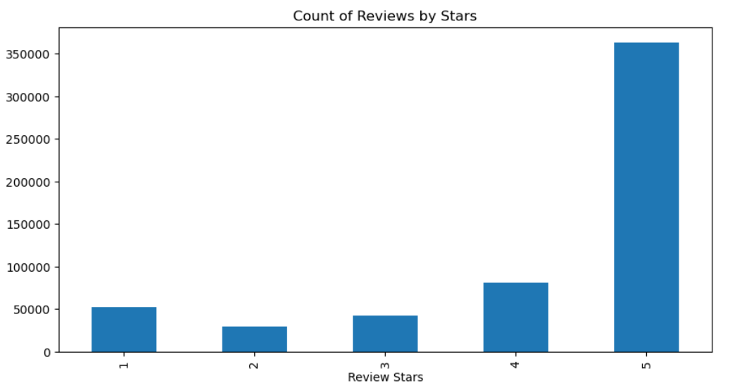

Feature Engineering
Text data was converted into numerical format using TF-IDF vectorization, meaning that the review text was changed into numbers so the computer could analyse it.
.
Both unigrams (single words) and bigrams (common word combinations) were used to better understand what customers were saying
This approach improves the model’s ability to understand context in reviews.

Model Training
A Naïve Bayes classification model was trained to predict sentiment.
The dataset was split into training and testing sets using an 80/20 split.
Two models were developed: a baseline model and an improved model using n-grams.

Model Evaluation
The improved model showed better accuracy and overall performance compared to the baseline model.
It was more effective at identifying negative sentiment due to its ability to understand phrases.
Evaluation metrics such as accuracy, precision, recall, and F1-score were used.

Key Findings
Common complaints include poor packaging, inconsistent taste, and delivery delays.
Frequently praised features include good flavour, value for money, and product quality.
Overall sentiment is largely positive, but negative reviews highlight important areas for improvement.

Recommendations
Improve packaging to reduce damage during delivery.
Maintain consistency in product taste and quality.
Address delivery issues to improve customer satisfaction.
Use sentiment analysis dashboards to monitor customer feedback in real time.

